CHAPTER 1

INTRODUCTION

1.1 Introduction
All plants and animals need water to survive. There can be no life on earth without water. Because 60 percent of our body weight is made up of water. Our bodies use water in all the cells, organs, and tissues, to help regulate body temperature and maintain other bodily functions. Because our bodily functions. Because our bodies loss of water through breathing, sweating, and digestion, it’s crucial to rehydrate and replace water by drinking fluids and eating foods that contain water.

1.2 Drinking water
Fluids and hydration are crucial for the bodily functions of humans, especially when it comes to drinking water. As you probably remember, 60-80 percent of the human body is water. However, the amount of fluid in our bodies varies, depending on certain factors, such as age, condition of internal organs, and health.
- Delivering essential nutrients to all organs.
- Oxygen supply to the lung and maintaining heart function.
- Release of recycled substances and ensuring the stability of the internal environment.
- Maintaining the normal body temperature.
- Helping the immune system resist diseases.

Other Benefits of Drinking Water
- It improves the condition of nails, skin, and hair, while dehydrated skin always looks dry and may cause acne problems together with aging.
- Water prevents urinary infections: directly, water does not improve the kidney function, it helps remove toxins, when those accumulate and start corroding the mucous membrane, causing inflammation and pain.
- Improved digestion: the stomach produces the necessary amount of gastric juice, with the right amount of water in the body.
- Lower blood pressure: the body can compress blood vessels, when it lacks water, which could lead to increased pressure.
- water relieves joint pain: it helps to stay in good shape and does not allow cartilage to wear out.
- Less headaches: if the body is dehydrated, headache is the first signal

  - Distribution of water on earth:

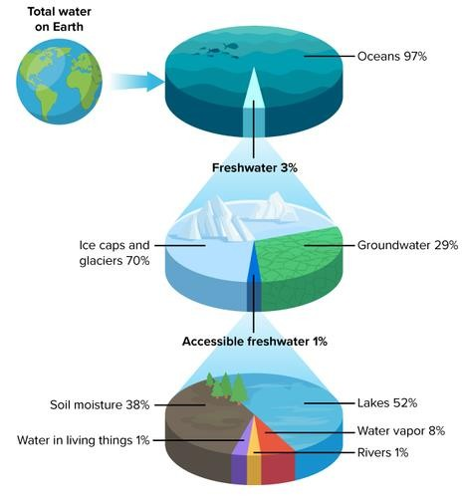
Figure 1.1 Distribution of Water

  - Study Area:
A Lake is an open area filled with Water, surrounded by land. Lakes, the major life supporting systems, are facing ecological degradation today, due to undesirable anthropogenic activities. Madiwala Lake is one of the biggest Lakes in Bengaluru and is situated near BTM Layout. It is located in between 12°54'28" north and 77°37'0" east in Bangalore city. Madiwala Lake is managed by Karnataka State Forest Department. Madiwala Lake is selected a study area to analyse and assess its Water Quality, which is nearly 114.3 hectare in area Lake water is contaminated through the unwanted activities of human and animals. Thus, the lake water is getting unsuitable for the Domestic purposes. Madiwala Lake is investigated in this study.
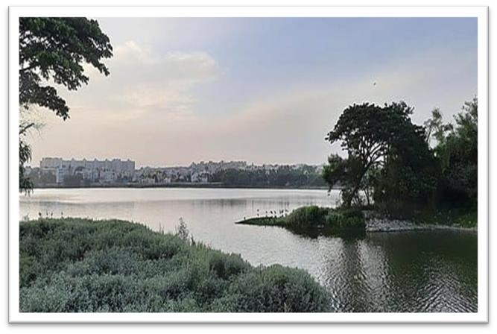
Figure 1.2: Madiwala lake
  - Aim and Objective of Study:
Based on the above discussed information the present minor project titled “WATER QUALITY ANALYSIS OF MADIWALA LAKE IN BANGLORE CITY “is selected. The objectives of the project are:
  - To determine the physical parameters like taste and odour, colour, solids and electrical conductivity.
  - To determine the chemical parameters like pH, acidity, alkalinity, hardness, solids etc.
CHAPTER 2

LITERATURE REVIEW

LITERATURE PAPER 1
Author & title: Soma Biswas1, Indhu Philip1, Saranya Jayaram1 and Suma Sarojini1
Endophytic bacteria Klebsiella spp. and Bacillus spp. from Alternanthera philoxeroides in
Madiwala Lake exhibit additive plant growth-promoting and biocontrol activities
Year & journal: 2023 Genetic Engineering and Biotechnology Outcome of research:
- The use of endophytes to improve plant growth and protect crops from pathogens can be the most sustainable and cost-effective approach in agriculture as it is in tune with the natural settings of the environment.
- In the present study, the A. philoxeroides stem isolate, K. pneumoniae showed multiple PGP traits that resulted in improved germination and vegetative growth of V. unguiculata plant. B. amyloliquefaciens and B. subtilis showed good extracellular enzyme production and antimicrobial activity along with plant growth promotion.
- Given the multiple PGP attributes of these strains, these can be commercially utilized in agriculture instead of chemical fertilizers. Thus, a consortium of these isolates could be further used as bioinoculants for improving plant growth in crop plants after validation by field trials, to increase crop yield under salinity stress.
- These kinds of studies align with the United Nations SDGs (Sustainable Development Goals) aiming at finding means to improve crop productivity without harming the environment much, as indeed it is the need of the hour.
- The isolated bacterial endophytes reported in this study can be utilized as PGP promotion and biocontrol agents in agricultural applications, to enhance crop yield under salinity stress. The isolate K. pneumoniae may be used as a biofertilizer in sustainable agriculture and more work can be done to optimize the best
formulations for its application as a microbial inoculant for crops.

LITERATURE PAPER 2
Author & title: Bisweswar Gorain, V.R. Ramakrishna Parama and Srijita Paul.
Heavy Metals Contamination in Madiwala and Lalbagh Lakes of Bengaluru, Karnataka:
Effect of Idol Immersion Activities
Year & journal: 2018 International journal current microbiology and applied sciences ➢ Outcome of research:
- The degradation is mainly due to encroachments; eutrophication loads and silt deposition. The principal causes for the deterioration of water quality in lakes are the discharge of domestic effluents, partially treated or untreated municipal sewage and several toxic pollutants of industrial origin.
- These anthropogenic activities are also responsible for heavy metals contamination. Besides these, immersion of painted idols, reported to contain different heavy metals was also found to be a potential source of heavy metal pollution in the lake Water
- The decrease in pH may be attributed to the decomposition of organic materials added during the immersion of idols as well as from the other sources.
- The EC of the Madiwala lake water increased from 1 to 1.32 dSm-1after 14 days of immersion. At the 30th day, the reduction in EC of the Madiwala lake water was might be due to the addition of different salts during the immersion activities
- The BOD of Madiwala Lake, in the pre-immersion period was 19.5 mgL-1 which increased to 26.4 mgL-1 one month after immersion. However, with time the BOD again decreased to 19.5 mgL-1
- The COD of Madiwala lake showed a steep increase from 175.5 mgL-1in the pre immersion period to 232.7 mgL-1at the post immersion period.

LITERATURE PAPER 3
Author & title: Alimuddin Physical-Chemical Parameters of Water in Madiwala Lake of Bangalore
Year & journal: 2013
Outcome of research:
- Water is one of the important sources, to sustain life and has long been suspected of being the source of much human illness. Source of surface water and ground water have become increasingly contaminated due to increased industrial and agricultural activity.
- The quality of surface water is largely affected by natural processes (weathering and soil erosion) as well as anthropogenic inputs (municipal and industrial wastewater discharge). The anthropogenic discharges represent a constant polluting source, whereas surface run off is a seasonal phenomenon, largely affected by climatic conditions. The public desires water that is low in hardness and total solids, non- corrosive and non- scale forming.
- Temperature influences the process behaviour in lakes and its measurement was necessary to get overall view of temperature regime during the sampling period.
- The photosynthesis and respiration of algae in eutrophic waters are known to influence the pH. Dissolved oxygen (DO) is not specified in drinking water standards since it influences all biological and chemical processes, it must be measured during water quality assessments. Dissolved oxygen below 5mg/l affects the functioning of aquatic communities.
- BOD has been traditionally used as an indicator providing an approximate measure of degradable organic matter present in the water. Unpolluted water usually has BOD of 2 mg/l or less and WHO standard indicated as 6 mg/l, although Madiwala lake exceeded this limit, the lake also exceeded permissible limit of 6 mg/ l said by the WHO standards.
- Phosphate is largely responsible for eutrophic condition and if it is not limiting.
Cyanobacteria can fix nitrogen from the atmosphere and develop algal blooms.
- The aquatic macrophytes was not cleared at all from the Madiwala lake, tend to accumulate vast quality of organic matter and this could account for the differences in sulphate.
- During the study period, Madiwala and around villagers were seen washing clothes in the lake and the detergents used were promoting algal blooms.
- The aesthetic quality water, especially its green colour and the undesirable odour associated with algae is a strong deterrent for drinking, although the water quality managers parameters. This lake mainly used for watering animals and domestic purposes other than drinking.

LITERATURE PAPER 4
Author & title: B. Anupama, Aboud S. Jumbe and N. Nandini
Assessment of Water Quality in Madiwala Lake, Bangalore in Relation to Faecal Contamination
Year & journal: 2009 Nature Environment and Pollution technology An International Quarterly Scientific Journal
Outcome of research:
- The lake covers full extension of 114.16 ha and a water spread area of 7,80,802 m². The wetland area which acts as a buffer and dilution zone for the treated wastewater coming from the nearby waste water treatment plant is about 24.74 ha. The water holding capacity of the lake is 2,26,757 m³.
- Faecal coliforms are of Gram negative, facultative, anaerobic, rod-shaped bacteria that ferment lactose to produce acid and gas within 48 hrs at 35°C. E. coli bacteria are an excellent indicator of faecal contamination.
- This is based upon that the E. coli is abundant in human and animal faeces and not usually found in other niches. Moreover, faecal coliforms are a subset of total coliforms that grow and ferment lactose at elevated incubation temperature, hence also referred to as thermo-tolerant coliforms.
- This group consists mostly of E. coli but some other enteric such as Klebsiella can also ferment lactose at these temperatures and, therefore, can be considered as faecal coliform.
- It is concluded here that the environmental status of Madiwala lake with respect to microbial pollution is continuing to deteriorate.
- The presence of pathogens such as E. coli in the lake at dangerous and epidemic levels underpins the failure of the restoration efforts and especially the ineffectual operations of the nearby wastewater treatment plant. Moreover, lake encroachment continues unabated with raw sewage spilling openly across the western buffer zone of the lake into the water.
- It must be noted here that Madiwala lake is an important stop-over sanctuary for thousands of migratory bird species

LITERATURE PAPER 5
Author & title: Abida Begum, S. Hari Krishna, IrfaUlla Khan, M. Ramaiah, K. Veena, K.
Vinuta. Nutrients and heavy metal profile of madiwala lake, Bangalore south, Karnataka
Year & journal: 2008
Outcome of research:
- Lakes, the major life supporting systems, are facing ecological degradation today, due to undesirable anthropogenic activities. The undesirable activities and unscientific utilization of resources from the lakes have caused undesirable environmental problems, thus threatening the biodiversity sustained by it.
- Madiwala lake area is 114.3-hectare, shore line is 5.84 k.m., depth is 4.5m, breadth is 0.7km and length is 1.8 k.m. Karnataka State Forest Department carries out the routine maintenance of this lake.
- Madiwala lake receives sewage and storm water from surroundings localities. Untreated sewerage flows in to the lake from Bommanahalli CMC area kodichikkanahally side the lake is dirty, and full of hyacinth weeds.
- Heavy metals are not biologically degraded like many organic pollutants; thus, heavy metals tend to accumulate, particularly in sediments in association with organic and inorganic matter, and involves adsorption, complex formation and chemical combination.
- About half of the zinc and copper contribution to the environment from urbanization is from automobiles. Brakes release copper, while tire wear releases zinc. Motor oil also tends to accumulate metals as it comes into contact with surrounding parts as the engine runs, so oil leaks become another pathway by which metals enter the environment.
- On the road surface, most heavy metals become bound to the surfaces of road dust or other particulates. During precipitation, the bound metals will either become soluble (dissolved) or be swept off the roadway with the dust. In either case, the metals enter the soil or are channelled into a storm drain. Metal behaviour in the aquatic (streams, lakes and rivers) environment is surprisingly similar to that outside a water body. Streambed sediments exhibit the same binding characteristics found in the normal soil environment.
- As a result, many heavy metals tend to be sequestered at the bottom of water bodies. Some of these metals will dissolve. The aquatic environment is more susceptible to the harmful effects of heavy metal pollution because aquatic organisms are in close and prolonged contact with the soluble metals.
- Madiwala Lake receives untreated domestic sewage from residential areas in Bangalore city. Soil pH values as affected by industrial effluents. Nutrient contents of the Soil and water samples were analysed for N, P, K and S which are essential for plant growth. The higher contents of total nitrogen in soils are due to the untreated sewage water. Electrical conductivity is a measure of the dissolved salts present in soil and water.

CHAPTER: 3

OBJECTIVES OF WATER QUALITY ANAYSIS
- Assess the safety of water: Ensure that water is safe for consumption, recreational activities, and other uses by measuring contaminants.
- Monitor environmental health: Evaluate the condition of aquatic ecosystems by identifying pollutants that could affect aquatic life, biodiversity, and overall ecosystem balance.
- Detect pollution sources: Identify potential sources of pollution (e.g., agricultural runoff, industrial discharges) and their impact on water quality.
- To investigate the impacts of urbanization on Madiwala lake, where the problem of lake management is becoming a serious issue and to understand the present scenario and shortcomings.

CHAPTER 4

METHODOLOGY
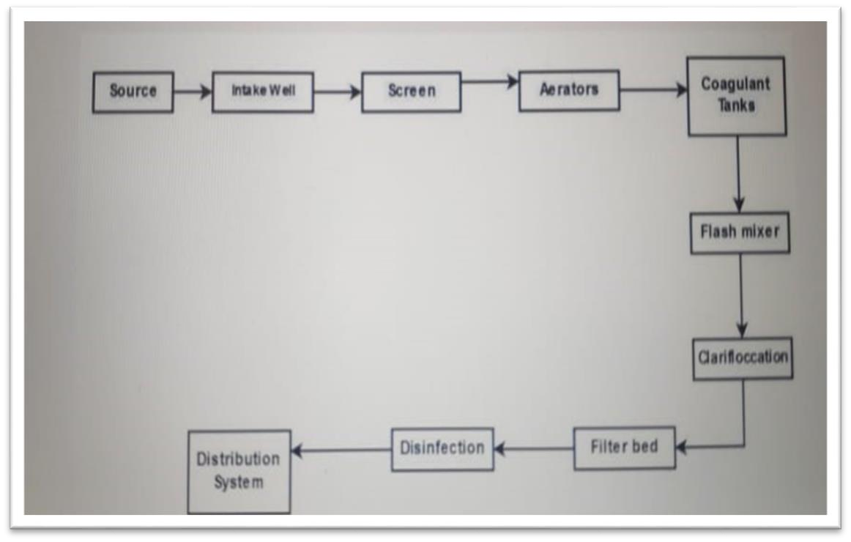
Figure 4.1: Block Diagram of Water Purification
Source:
The source water for a municipal surface water treatment plant is typically a local river, lake, or reservoir. There must be a method to get this water to the water treatment plant. Quite often, a series of pumps and pipelines transport the water to the treatment plant. Sometimes, as is the case of San Angelo, water from a reservoir such as Twin Buttes can be transported to the water treatment plant via a river.
Twin Buttes Reservoir is one of the water sources for San Angelo. The water is released into Lake Noseworthy where it is transported down the Concho River to the water treatment plant. At the water plant, large pumps are used to transfer the water up to the treatment facility. Treatment facilities are often engineered to utilize gravity water flow as much as possible to reduce pumping costs. Many water treatment plants utilize water from more than one source. Blending groundwater with surface water is a method often used to improve the quality of the final product.

Screening and Straining:
If you think about surface water sources, i.e., lakes, rivers, and reservoirs, you realize they contain varying amounts of suspended and dissolved materials. This material may include turbidity, colour, taste, odour, microorganisms, fish, plants, trees, trash, etc. The material may be organic or inorganic, suspended or dissolved, inert or biologically active, and vary in size from colloidal to a tree trunk. Some of these larger items can impede equipment in the treatment process, such as a tree limb getting stuck in a water pump impeller. So, the first process in conventional water treatment is to screen or strain out the larger items. This is often accomplished using a large metal screen, often called a bar screen, which is placed in front of the water source intake. Large items are trapped on the screen as the water passes through it. These screens must routinely be raked or cleaned off.

Chemical Addition:
Once the pre-screened source water is received into the treatment plant, chemicals are added to help make the suspended particles that are floating in the water clump together to form a heavier and larger gelatinous particle, often called floc. In this process, a chemical is added that reacts with the natural alkalinity in solution to form an insoluble precipitate. There are many different chemicals on the market that are used in this process. These chemicals are called coagulants. One of the most common that has been used for many years is aluminium sulphate, or alum. Some other very popular coagulants are ferrous sulphate, ferric chloride, sodium aluminate, activated silica, and compounds called polymers that are manufactured chemicals made up of repeated small units of low molecular weight combined into molecules with very large molecular weights. These polymers are classified as cationic polymers (positively charged), anionic polymers (negatively charged), and non-ionic polymers (neutrally charged). Regardless of which coagulant or combination of coagulants is used, they must be mixed very well with the water before they can form a heavier floc.

Coagulation and Flocculation:
A rapid mix unit is usually used where the coagulant is added to the water to provide a very quick and thorough mixing. The water mixing is then slowed to allow the water to come in contact with the forming floc and allow it to increase in size. The continued mixing must be gentle to allow the floc to grow and gain weight, but fast enough to keep it in suspension until you are ready for it to settle in the clarifiers. The process of adding a chemical to cause the suspended material to “clump” into larger particles is called flocculation or coagulation. The treatment unit where coagulation and flocculation is performed is called the “flocculator”.
Sedimentation and Clarification:
Once the flocculation process is complete, the water then passes over the weir in the flocculator and travels to the centre of the clarifier, or sedimentation basin. Here, the water makes its way from the centre of the clarifier to the saw tooth weir at the perimeter of the unit. As the water makes its way towards the weir, the large floc particles are allowed to settle out to the bottom of the clarifier. A rake continuously travels across the bottom of the clarifier and scrapes the settled floc to the centre of the unit. Pumps are used to pull the settled “sludge” out of the clarifier and send it to a sedimentation / disposal pond. The water that passes over the weir is collected and transferred to the filters. The reason clarification occurs before filtration is so the majority of suspended material can be removed prior to filtration, which avoids overloading the filters and thus allowing much more water to be filtered before the filters must be backwashed. Filtration
Clarified water enters the filters from the top. Gravity pulls the water down through the filters where it is collected in a drain system at the bottom of the unit. There are many different types of materials (media) used in filters. The most common being sand and gravel. Many conventional plants are now using granular activated carbon as the media of choice because it not only provides excellent mechanical filtration of particulate matter, but also removes organic compounds which can cause taste and odour problems.

Disinfection:
Once the water has gone through the filtration process, it is about as clear and clean as it can get. However, there may still be bacteria and viruses remaining. To ensure these are destroyed, there must be a disinfection process employed. The most common disinfection process used in the United States is chlorination. Chlorine comes in many different forms including chlorine gas (most common), chlorine dioxide, hypochlorite (bleach), and others. Whichever method is used, chlorine is added to the water in an amount to ensure all microorganisms are destroyed. Water plants monitor the chlorine levels continuously and very carefully in the treated water. They must add enough chlorine to ensure thorough disinfection of the water, but avoid adding excesses that can cause taste and odour problems when delivered to the consumer.

Storage:
Once the disinfection process is complete, the water is stored. Storage usually takes place in an underground storage tank called a “clear well”, and also in elevated storage tanks that are visible around town. There must always be an ample supply of water available in the event of emergencies. These can include power outages, fires, floods, etc.

Distribution:
So how does the water come out of your kitchen tap? The stored water is pushed through underground pipelines all over town in what is called a “distribution system”. The distribution system consists of large water pumps at the treatment plant, overhead water storage tanks, large pipelines, smaller pipelines, fire hydrants, valves, and water meters in your front yard.

CHAPTER 5

DETEMINATION OF SAMPLE PARAMETERS
Water sample is collected from the area of MADIWALA LAKE BANGLORE CITY and it’s tested for drinking purpose. The different parameters which are determined in this project are:

- pH of water
- Temperature
- Taste
- Odour
- Turbidity
- Alkalinity
- Chloride
- Dissolved oxygen (DO)
- Total hardness
- Total dissolved solids
- Total solids
- Sulphate
- Nitrate
- Phosphate
- Acidity
- Bio chemical oxygen Demand
- Potassium

5.1 pH
Introduction:
pH stands for hydrogen (H) potential and it represents the measure of concentration of H+ ions in a solution. As a mathematical consequence of the formula that defines pH, the units on the pH scale range from 0 to 14. A value of 7 indicates neutrality, values less than 7 are called acidic, and values greater than 7 are called basic or alkaline. Values close to 0 to 14 represent extremes acidity and basic, respectively. In general, the pH of water for drinking purpose should be between 6.5 and 8.5.

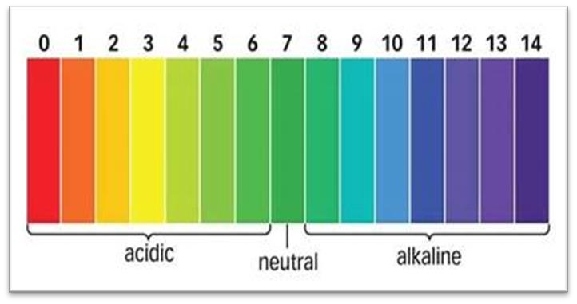
Figure 5.1: pH scale
Chemicals Required: Buffer tablet of pH values 4 and 9.2
Reagents preparation: Buffer solution of pH value 4 and Buffer solution of pH value 9.2 Buffer tablet of pH value 4 is dissolved in 100 ml of distilled water. This solution should preferably be stored in a plastic bottle in cool place. Buffer tablet of pH value 9.2 is dissolved in 100 ml of distilled water. This solution should preferably be stored in a plastic bottle in cool place.

Electrometric method:
- Wash the combined electrode of pH meter with distilled water and clean the same with distilled water.
- Dip the combined electrode in the buffer solution of pH value 4.
- Adjust the temperature by the adjustment knob to an ambient (room) temperature.
- If the instrument shows the reading as 4 then it is in order if not, adjust the reading to 4.0 by calibration adjustment knob.
- Wash the electrode of pH meter with distilled water and clean the same with distilled water and dip it to the buffer solution of pH value 9.2.
- Note the reading if the instrument shows the reading as 9.2 then it is in order otherwise use the calibration adjustment knob and bring the reading to 9.2.
- Repeat the above procedure until the meter shows reading as 4 when electrode is dip in buffer solution of pH 4 and shows reading as 9.2 when electrode is dip in buffer solution of pH value 9.2.
- Now the instrument is calibrated.
- After cleaning the electrode dip in the sample for which pH value is to be found out.
- Directly record the reading from the meter without doing any adjustments.

1. Using the pH meter
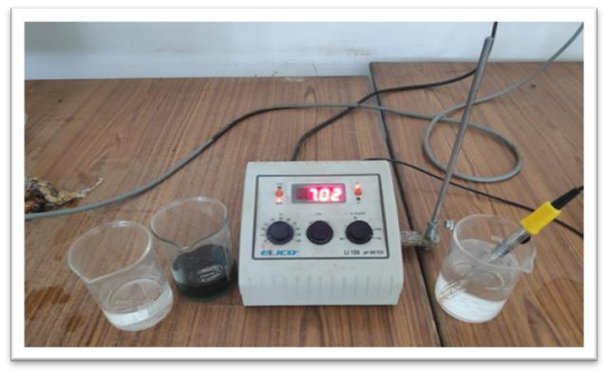
Figure 5.2: pH meter

- Calibrate the electrode with two standard buffer solutions of pH 4 and 9.2
- The sample temperature is determined
- Rinse the electrode thoroughly in distilled water and carefully wipe it with a tissue paper
- Dip the electrode into the given sample solution and wait up to 1 min for a steady reading.
- The reading is taken after the indicated value remains constant for about a minute.

2. Using pH paper
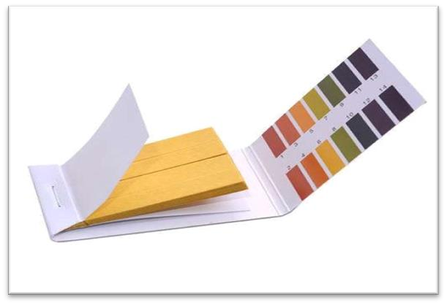
Figure 5.3: pH paper

- Dip the paper strip into the given sample after removing a colour appears on the pH paper.
- Compare the resulting colour with standard colour this method gives the appropriate or approximate pH value of the sample

Table 5.1: Result of pH

Sample No | pH meter | pH paper
1 | 7.9 | 8

5.2Alkalinity

Introduction
Water alkalinity is a measure of the concentration of bases in a solution or the ability to neutralize acids in water. It can also be referred to as the buffering capacity of water. Examples of bases are carbonates, bicarbonates, magnesium bicarbonate, ammonia, borates, phosphates, silicates, and organic bases. For all practical purposes, carbonates and bicarbonates are the main contributors to the alkalinity of water. Since corrosion is caused by calcium carbonate, the corrosion process is dependent on the pH and alkalinity of the water.
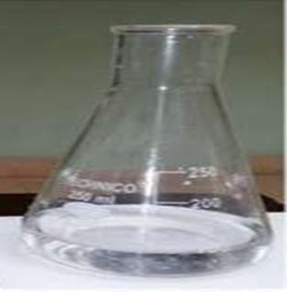
Figure 5.4: Phenolphthalein Alkalinity
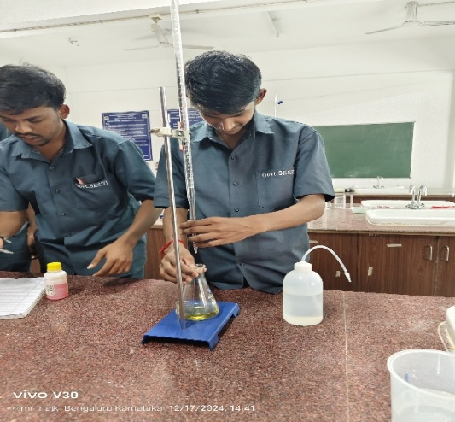
Figure 5.5: Methyl Orange Alkalinity Titration

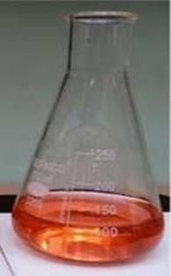
Figure 5.6: Methyl Orange Alkalinity

PROCEDURE:
- Using a measuring cylinder exactly measure 50ml of sample and pour it in a conical flask.
- Fill the burette with 0.02N Sulphuric acid.
- Add few drops of phenolphthalein indicator to the sample in the conical flask.
- If the sample in the conical flask turns pink then titrate it against 0.02N Sulphuric acid till the pink colour disappears and it becomes colourless.
- Note down the volume of Sulphuric acid added (V1). The value of titration is known as partial alkalinity.
- This value is used in calculating the phenolphthalein alkalinity P.
- If the sample remains colourless after addition of Phenolphthalein indicator, do not titrate, then P is zero.
- To the same solution in the conical flask add few drops of Methyl orange indicator and the sample turns yellow.
- Continue the titration from the point where stopped.
- Titrate the sample against Sulphuric acid till the solution becomes Orange.
- The entire volume (V2) of Sulphuric acid added is noted down and is accountable in calculating the total alkalinity T.
CALCULATIONS:
1.Phenolphthalein Alkalinity= Vol of Sulphuric acid (V1) /Vol. of sample X 1000
= 0/50*1000
= 0mg/lit
2. Total Alkalinity = Vol of Sulphuric acid (V2) / Vol. of sample X 1000
= 4.75/50*1000
= 95mg/lit
Table 5.2: Result of Alkalinity
Sample  No | Volume of sample (ml) | Phenolphthalein |  |  | Methyl orange
Sample  No | Volume of sample (ml) | Initial Burette reading | Final Burette reading | Vol. of  0.02N  Sulphuric acid  (ml) | Initial Burette reading | Final Burette reading |  | Vol. of 0.02N  Sulphuric acid (ml)
Sample1 | 50 | 0 | 0 | 0 | 0 | 4.75 | 4.75

RESULT:
  - Partial or Phenolphthalein Alkalinity of given water sample is = ___0_mg/lt.
  - Total Alkalinity present in given water sample is = __95_mg/lt.

5.3 Acidity
Introduction
The acidity of natural water is primarily due to dissolved CO2 and is defined as the capacity to neutralize bases. However, in water polluted by trade wastes acidity may be because of mineral acids (below pH 4). Acidity due to CO2 is present within a pH range 4.5-8.3. When the pH of a Sample is more than8.3, acidity is absent.

PROCEDURE:
- C02 Acidity:

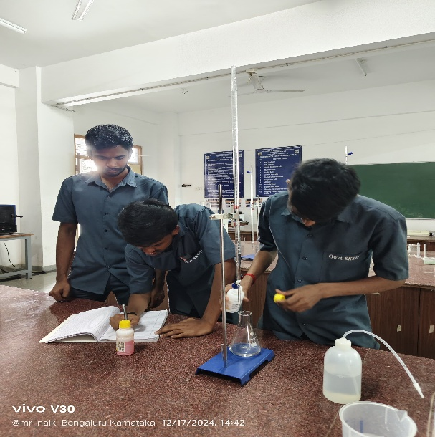
Figure5.7: C02 Acidity Ttration
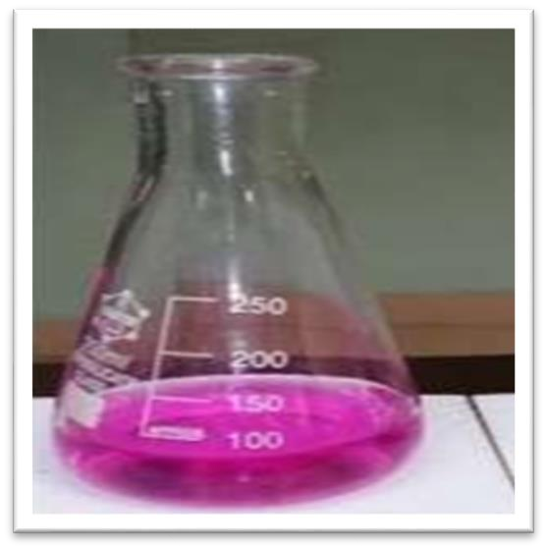
Figure5.8: C02 Acidity
- Take 50 ml of given water sample in a conical flask.
- Add 3 to 4 drops of Phenolphthalein indicator, the solution is colourless.
- Titrate against NaOH of 0.02N till the colour changes to pink.
- Note down the volume of NaOH added as V1.

2.Mineral acidity:
- Take 50 ml of given water sample in a conical flask
- Add 2-3 drops of Methyl Orange indicator the colour changes to orange 3. Titrate against NaOH of 0.02N till the colour changes from Orange to Yellow
- Note down the volume of NaOH added as V2.

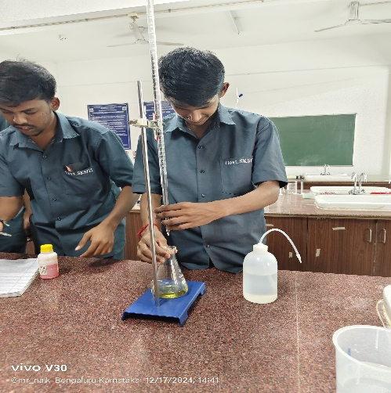
Figure 5.9: mineral Acidity
Table 5.3: Result of Acidity
Sample  No | Volume of  sample (ml) |  | Phenolphthalein |  |  | Methyl orange
Sample  No | Volume of  sample (ml) | Initial Burette reading | Final Burette reading | Vol. of 0.02N  Sulphuric acid (ml) | Initial Burette reading | Final Burette reading | Vol. of 0.02N  Sulphuric acid (ml)
Sample 1 | 50 | 0 | 0.45 | 0.45 | 0 | 0

CALCULATIONS: 1.C02 Acidity = V1/Vol of Sample X1000 = (mg/lit)
= 045/50*1000
= 9 mg/lit
2. Mineral acidity = V2/Vol of Sample X 1000= (mg/lit)
= 0/50*1000
= 0 mg/lit
3.Total acidity = C02 Acidity + Mineral acidity = (mg/lit)
= 9+0
= 9 mg/ lit
RESULTS:
  - CO2 acidity = 9mg\lit
  - Mineral acidity = 0mg\lit
  - Total acidity = 9mg\lit
5.4 TOTAL HARDNESS:

Introduction
- Hardness is caused due to the presence of multivalent cations, mainly Ca+ and Mg+ in water.
- Hard water has many dis advantages capacity to precipitate soap. Thus, measurement of water hardness is very necessary.
- Total hardness of water is the sum of Ca+ and Mg+ concentration of water. The results are expressed as calcium carbonate, in mg/L, that is,” mg/L as
- CaCO3
- 4When total hardness is numerically greater than the sum of carbonate and bicarbonate alkalinity for a water sample, the amount of hardness equivalent to the carbonate plus bicarbonate alkalinity is called” carbonate hardness”.
- The amount of hardness in excess of this is called” non carbonate hardness”. When hardness numerically is equal to or less than the sum of carbonate and bicarbonate alkalinity, all hardness is carbonate hardness, and non-carbonate hardness is absent
PROCEDURE:
1.Determination of Total Hardness:
- Take 50ml of given water sample in a conical flask.
- Check the pH & adjust the pH to 10 by adding 1-2ml of ammonia buffer solution.
- Add 2-3 drops of EBT indicator the colour changes to wine red.
- Titrate against EDTA till the colour changes from wine red to blue.
- Note down the volume of EDTA as ‘V1’
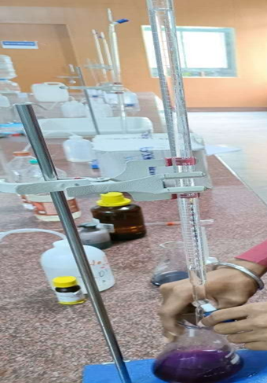

Figure 5.10: Titration of Total hardness

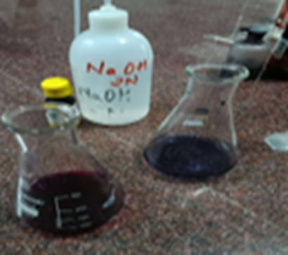

Figure 5.11: Total hardness

2.Determination of Ca hardness:
- Take 50ml of given water sample in a conical flask.
- Check the pH and adjust the pH to 12 by adding 1-2ml of NaOH of 2N.
- Add a pinch of murexide indicator, the colour changes to pink
- Titrate against EDTA of 0.01 molarity till the colour changes from pink to purple.
- Note down the volume of EDTA added as ‘V2’.
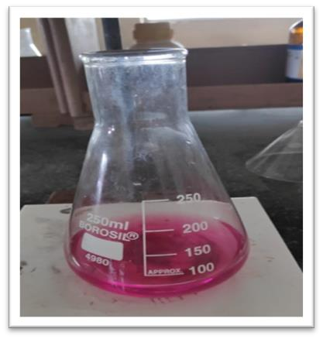

Figure 5.12: Starting point Calcium hardness
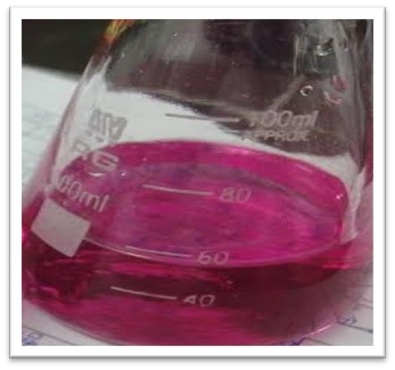
Figure 5.13: End point of Calcium hardness.

Table 5.4: Result of Total hardness
Sample  No | Volume of  sample (ml) |  | Total hardness |  | Calcium hardness
Sample  No | Volume of  sample (ml) | Initial Burette reading | Final Burette reading | Vol. of 0.01N  EDTA  (ml) | Initial Burette reading | Final Burette reading | Vol. of 0.01N  EDTA  (ml)
Sample 1 | 50 | 0 | 9.75 | 0.45 | 0 | 4.35 | 4.35

CALCULATIONS:
    - Total Hardness = V1/Volume of sample *1000 (mg/litre)
= 9.75/50*1000
= 195 mg/lit
    - Calcium Hardness = V2/Volume of sample *1000(mg/litre)
= 4.35/50*1000
= 87 mg/lit
    - Total hardness = Calcium hardness + Magnesium hardness(mg/litre)
= 87+108
=195 mg/lit
    - Magnesium hardness = Total Hardness - Calcium Hardness (mg/litre)
= 195-87
= 108 mg/lit
    - Amount of Ca++ ions = V2 X 400/Volume of Sample
= 4.35*400/50
= 34.8
    - Amount of Mg++ ions = 0.243 X Mg Hardness
= 0.243*108

= 26.4
RESULTS:
  - The amount of total hardness of given water sample is = 195mg/lit
  - Calcium hardness is = 87 mg/lit
  - Magnesium hardness is =108mg/lit
  - Amount of Ca++ ions =34.8
  - Amount of Mg++ ions =26.4

5.5 TOTAL SOLIDS

Introduction
The term ‘solid refers to mater either filterable or non-filterable that residue upon evaporation and subsequent drying at a defined temperature. Further categorization depends upon the temperature employed for drying and ignition. Different forms of solids are defined on the basis of method applied for their determination. Solids may affect water or effluent quality adversely in number of ways. Water with high dissolved solids may induce an unfavourable physiological reaction in the transient consumer and generally are of inferior palatability. Highly mineralized water is unsuitable for many industrial applications. High suspended solids in waters may be aesthetically unsatisfactory for such purposes as bathing. Analysis of total solids is important to decide upon the various unit operations and processes in physical and biological waste water treatment and to assess its performance evaluation. For assessing compliance with regulatory agency, waste water effluent Limitation for various forms of solid act as indicating parameters.

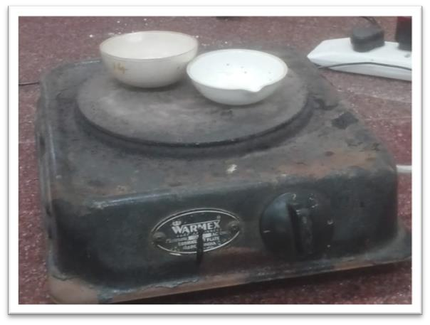
Figure 5.14: Total Dissolved Solids

Procedure:
- Determination of Total Solids:
  - A clean crucible is ignited in a Muffle Furnace and after partial cooling in air it is cooled in a desiccator
  - The empty weight of crucible is noted as W1 grams.
  - 3Measure 25 ml of given water sample and place it in crucible.
  - Evaporate sample at 100 ˚C on the water bath and dry it in an oven at 103 ˚C for an hour
  - Dry to a constant weight at 103 ˚C.
  - Cool it in a desiccator.
  - Note down the weight of crucible + Residue as W2 grams.
Calculate total solids as (W2-W1)/ (volume of sample) x 10^6
……. Mg/lit
- Determination of total dissolved solids:
  - A clean crucible is ignited in a muffle furnace and after partial cooling in air it is cooled in a desiccator
  - The empty weight of crucible is noted as W3 grams
  - Measure 25 ml of given water sample and filter it through a What man filter paper 40/41/42 the suspended solids are retained on filter paper and the sample contains only dissolved solids
  - Place this filter sample in crucible and evaporator sample at 100˚C on the water bath and dry it in an oven 103˚C for 1 hour
  - Dry to a constant weight at 103˚C
  - Cool it in a desiccator
  - Note down the weight of crucible + Residue as W4
Calculate number of dissolved solids as (W4 -W3)/ (volume of sample) x 10^6
……. Mg/lit

CHAPTER 6
RESULT AND DISCUSSION:

6.1 Results
As per BIS for drinking water (IS 10500-2012)
Parameters | Unit | Acceptable Limit | Permissible Limit | Result | Test Method
Water  Temperature |  |  |  | 24.5 | IS 3025(part-9): 2023
odour | ----- | Agreeable | Agreeable | Non-Agreeable | IS 3025: part 5: 2018
Taste | ----- | Agreeable | Agreeable | Non-Agreeable | IS 3025: Part 7: 2017
pH value | ----- | 6.5-8.5 | No relaxation | 7.9 | IS 3025: part 11: 2022
Turbidity | NTU | 1 | 5 | 8.2 | IS 3025: part 10: 2023
Total Dissolved Solids | mg/L | 500 | 2000 | 398 | IS 3025: part 16: 2023
Total Alkalinity as  CaCO3 | mg/L | 200 | 600 | 177 | IS 3025: part 23: 2023
Total Acidity | mg/L | - | 50 | BOL (DL = 1.0) | IS 3025 (part 22): 2023
Total Hardness as CaCO3 | mg/L | 200 | 600 | 143 | IS 3025: Part 21: 2009 (RA:2019)
Sulphate as SO4 | mg/L | 200 | 400 | 18 | APHA 4500 SO4-F 24th Edition 2023
Chloride as Cl | mg/L | 250 | 1000 | 67 | IS 3025: part 32: 1988 (RA:2019)
Nitrate as NO3 | mg/L | 45 | No  Relaxation | 5.3 | IS 3025(part 34): 1988 (RA:2019) / APHA 24th Edn 4500 NO3 B: 2023
Dissolved Oxygen | mg/L | 1 | 5 | 5.1 | IS 3025 (part 38): 1989
Phosphate | mg/L | - | 1 | 1.5 | IS 3025 (part 31)

  - The pH of the lake water is 7.9 which is greater than 7, so the water is basic in nature and is within the permissible limits.
  - Total Dissolved Solids, Total Alkalinity (CaCO3), Total Hardness (CaCO3) all these parameters are also within the permissible limits.
  - Sulphate is 18 mg/lit, Chloride is 67 mg/lit, Nitrate is 5.3 mg/lit all these parameters are also within the permissible limits.
  - As the water is Alkaline in nature its Total Acidity content is too less i.e., 1.0 mg/lit.
  - The Dissolved Oxygen content is 5.1 mg /lit which shows that the decomposition occurs
  - When Organic Matter enters the water, microorganisms break it down through the process of Decomposition. During Decomposition, microorganisms like bacteria, algae consume oxygen to metabolise the organic matter.
  - The Turbidity of the Water is 8.2 NTU which is greater than the permissible Limit which shows that the water is highly turbid in nature because of due to heavy rains the soil enters the lake and other materials might enter Lake through sewage water. The water is highly turbid which shows that the water consists of more Suspended and colloidal solids.

6.2 CONCLUSION:
The overall conclusion of the Water Quality Analysis of Madiwala Lake and the results of some physical and chemical parameters are compared to the Drinking Water Standards of IS l0500: 2012.
The Turbidity can be controlled by

  - Reduce Soil Erosion: Installing erosion control measures such as silt fences, sediment barriers, and terracing on construction sites or in agricultural areas can prevent soil from entering the lake.
  - Control Fertilizer Runoff: Excess nutrients, particularly Nitrogen and Phosphorous from Fertilizers often promote algae growth which increases Turbidity. Often try to control the enter of Agricultural Water into Lake.
  - Sediment Traps and Dams: Installing sediment Traps, check dams, or other sediment-retention structures in the watershed can help catch suspended particles before they reach the lake.
- The Phosphate content in the Lake is 1.5 mg/lit which is greater than the permissible limit The reason for more Phosphate content in Lake Water is due to the Dhobi Ghat around the Lake Where the water enters the Lake through washed Clothes and used detergents

Water with high phosphate content can be treated using a variety of methods, including:
- Chemical precipitation: The most common method for removing phosphorus from water, this process involves adding chemicals like iron, aluminium, or calcium hydroxide to the wastewater. The chemicals react with the phosphate to form a precipitate that settles out of the water.
- Biological removal: Bacteria like polyphosphate-accumulating organisms (PAOs) can be added to the water to remove phosphorus.
- Physical removal: Methods like sand filtration and membrane technologies can be used to remove phosphorus.
- Adsorption: Carbonaceous materials like activated carbon, charcoal, and graphene can be used to remove phosphate from water.

- Constructed wetlands: A low-cost, environmentally friendly option that uses natural processes to break down organic matter in the wastewater. The reeds in the wetland digest the phosphates.
- The Lake water is highly turbid and if it is treated it requires coagulants like Alum in order to remove suspended minute particles. The water consists of more organic matter which should be decomposed for Domestic usage. The higher phosphate content can be reduced by above mentioned any one of the treatment methods.

REFERENCE:
- Indian Standard Drinking Water-Specification (Second Revision) IS 10500: 2012
- B. Anupama, Aboud S. Jumbe and N. Nandini "Assessment of Water Quality in Madiwala Lake, Bangalore in Relation to Faecal Contamination" Nature Environment and Pollution Technology • Vol. 8, No. 3, 2009: 497-501, 2009. Accessed: December 13 2024
- . Bisweswar Gorain, V.R. Ramakrishna Parama and Srijita Paul " Heavy Metals Contamination in Madiwala and Lalbagh Lakes of Bengaluru, Karnataka: Effect of Idol Immersion Activities " Int.J.Curr.Microbiol.App.Sci. 7(10): 2254-2263, 2018. Accessed: December 5 2024
- Alimuddin " Physical-Chemical Parameters of Water in Madiwala Lake of Bangalore" Environmental Sustainability: Concepts, Principles, Evidences and Innovations: 19-23, 2013. Accessed: December 7 2024
- Abida Begum, S. Hari Krishna, Irfanulla Khan, M. Ramaiah, K. Veena, K. Vinuta " NUTRIENTS AND HEAVY METAL PROFILE OF MADIVALA LAKE, BANGALORE SOUTH, KARNATAKA" et al Abida Begum: 572-598, 2008: Accessed December 9 2024

